P&C Meeting | Oakhill Drive Public School
Date: Monday 13th November 2023 |  | Next meeting: 11th December 2023
Type of meeting | P&C Monthly Meeting – school lib lab
Facilitator | Janice Love - Vice President
Minute taker | Dina Hayes – Secretary
Attendees | Janice Love (JL), Dina Hayes (DH), Susie Croker (SC), Nic Rogencamp (NR), Anna Myasnikova (AM), Katie McAndrew (KM), Dawn Tan, Katrina Hall (KH), Joanna Wang, Angela Black (AB), Helen Cheung, Joelene Cheney, Faran Daneshari, Elisa Tan, Renhua Song, Natalie O’Brien (NO), Debbie Ma, Chris Wang
Apologies | Betty Ploeg, Faizz Fatah, John Richards, Tuyet Fellows, Jo Cope
Acceptance of previous minutes/financials | Accepted: | AB | Seconded: | AM
Report on Health and Safety Issues |  | Nil to report

Outstanding Actions Review | Time: | Speaker:
Action Items / Progress | Responsible |  | Original | Expected/Outcome
Transfer Band HQ asset to the Department | Principal/  Treasurer |  | August 2023

Presidents Report | Time: 20 mins | Speaker: JL/DH/KM
Acknowledgement of country.

Volunteering video: work on the video has commenced with assistance from Mrs. Pascoe. Some filming for the video was carried out during the meeting, and attendees were invited to be included by sharing their involvement of volunteering for the school.

Last meeting for 2023 and AGM: to be held on Monday 11th December. Notice of AGM sent to all families via Sentral in October. Additional reminder notices will also be sent via Sentral app between now and the meeting date.

Call for nominations for P&C office bearers for 2024: all positions on the P&C will become vacant after the last meeting. Nominations for all positions including President, Vice President x 2, Secretary, Treasurer, Community Events are now open and will be voted on at the AGM. Nominations can be sent to the P&C Secretary by Monday 4th December.

OSHC:

Infinity Warriors Basketball free lessons for Y children: this activity has been very popular. The Y is considering how to continue offering the activity whilst sharing the basketball courts with other community groups.

The Y approved shade sails: approval has been provided by the Y to install shade sails in the outdoor area. This has been a wish for the Y for some time and is a great outcome. It is not known when the sails will be installed.

Application for Community building partnerships grant: thank you to the P&C for passing on information for this opportunity. An application has been submitted with assistance from the school for the resurfacing of the outdoor area (sensory outdoor learning area/secret garden).

As a result of this building grant, a letter of invitation has been sent to the local MP for Castle Hill to visit the school/the Y, to see our vision for the grant funding if our application was successful.

Vacation Care Summer: rolls open from 13th Nov. 5 weeks to book. Notice in the school newsletter.

Changed days/hours in December: Mon 18th and Tue 19th Dec are ODPS staff development days, and the Y will be open from 8:30am to 4:30pm. The Y will be closed on Wed 20th, Thur 21st and Fri 22nd Dec.

Kindy Orientation: KM has been invited to speak about the Y at orientation. The team will have the Y room open with goodie bags, so that families can visit and have a more in-depth chat about their needs.

Y biggest afternoon tea: to be held in May 2024. Which Friday would be best to hold the event to not clash with school activities such as the Mother’s Day stall? School to advise.

Principal’s Report | Time: 15 mins | Speaker: NR/SC
Acknowledgement of Country
Academic Success: In 2022, we ranked in the ‘Top 100 Schools in NSW’ (private and public) and this year we improved on that, according to ‘Better Education Analysis’ by placing in the ‘Top 50 schools in NSW’. We placed 15th in the state. 8 high fee private schools & 6 NSW Public Schools; all with OC. According to this analysis, we are the top performing NSW DoE comprehensive public school, based on NAPLAN data. More importantly our data of Progressive Assessment Test (PAT) shows continuous growth and reducing the gap between bottom student and top student.

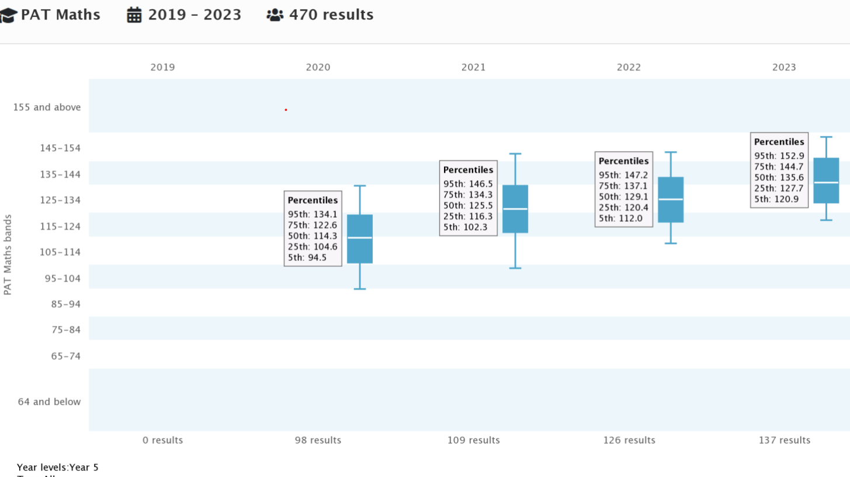

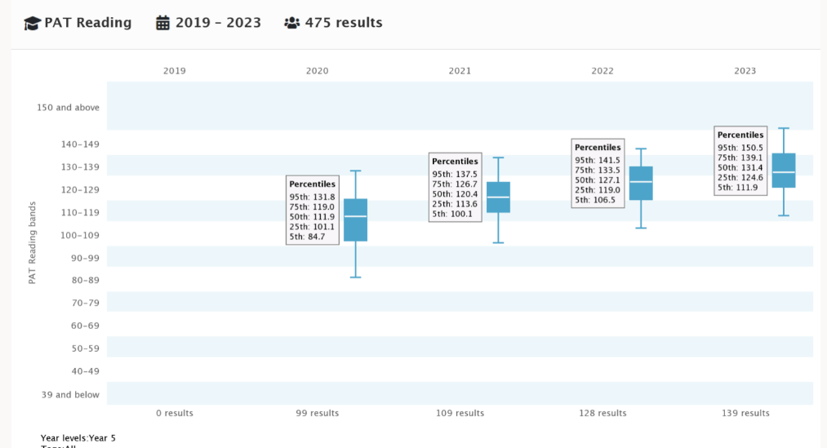

NAPLAN Year 5 NUMERACY: 2010-2022
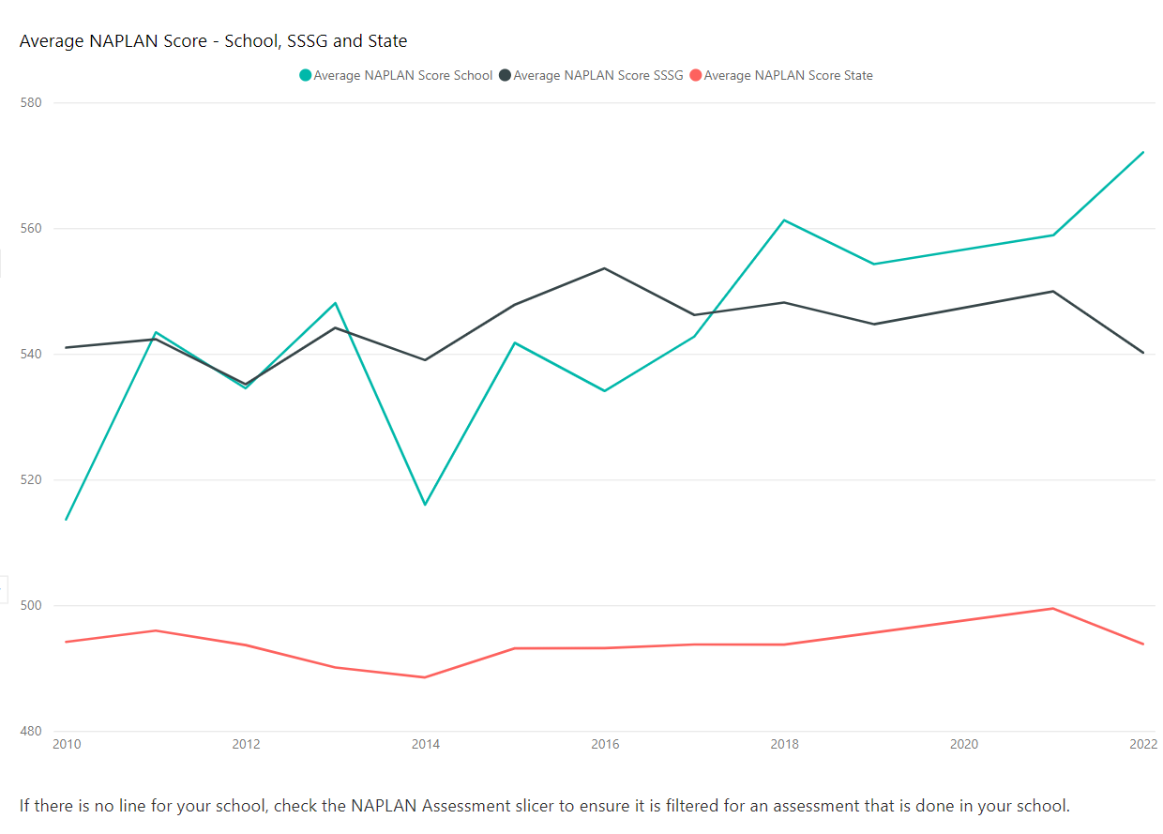

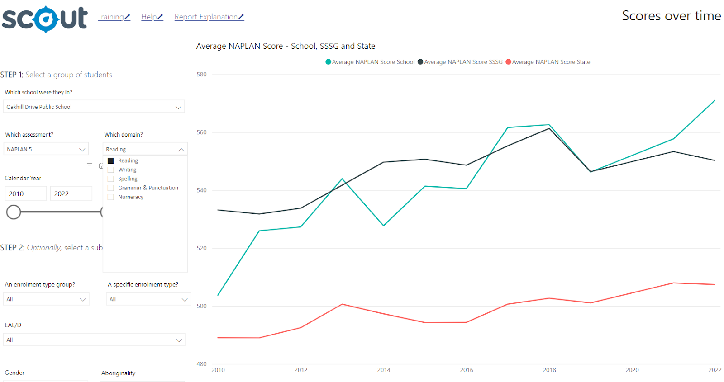

Continuous success: in sport, creative and performing arts, through competitions, eisteddfods and showcase events. We are very proud of our work and the results our school is making to improve student outcomes. We are celebrating but not resting. It remains our goal to establish strong foundations for learning and wellbeing in all our students, positioning them to build upon in all their future goals.

Merit selection panel: interviewed for the position of Assistant Principal 2024. The panel nominated a suitable candidate, and we are awaiting the approval of DoE to offer the position.

Improvements of grounds: around the basketball court and under the COLA have been completed and the ground looks much better. The area will remain secured for 1 month to allow the grass to grow. This work was approx. $80K funded by the DoE.

Lower oval improvements: proposed work was displayed to those in attendance. It includes a mini synthetic soccer field for K-1 students, nature play area and friendship circle. Anticipated expenditure $200K. DoE will put the plan out to tender. Hoping the P&C can help with this cost by contributing $50K.

A motion to allocate $50,000 of P&C funds to the cost of the Lower Oval rectification was put to members in attendance, and the motion was unanimously supported.

Kindergarten numbers for 2024: are low. We anticipate 80 students across 4 classes, compared to 90 students.

Friendships in classes: Our teachers know their students well and are placed to make judgements about suitable learning partnerships in the classroom. Best friends, neighbours, cousins may not always be suited in the same class. Some friendships are best kept in the playground. We are unable to guarantee your child will have their closest friends in their new class. Change can be easy for some children and difficult for others. It is crucial to approach this transition with a supportive and positive mindset. Our newsletters include strategies for parents to support the school to prepare their child for the potential changes in the school environment.

Gifts to Teachers: Our teachers do not expect gifts from families. Gratitude to your child’s teacher can be in the form of meaningful words in a card, flowers, chocolates. The NSW DoE has a policy around gift giving. Teachers must declare all gifts over $50 in value. A maximum combined class gift should not exceed $150. Our community faces multiple expenses at this time of year, and we do not intend to add to your burden.

Treasurer’s Report | Time: 5 min | Speaker: JL
Year End financials/audit review: the annual financial accounts are with the auditor, who has completed an initial review and requested some further information which has been provided to her. We are on track to present the final audited report at the December meeting.

New accounting system migration: the need to finalize the annual accounts is delaying the completion of the migration onto our new accounting system Xero. We are waiting on final balances as the basis for the transfer of accounts. Bank accounts are all linked to the new system and all transactions from 1 October captured in Xero.

Subcommittee reports: reports are yet to be created in Xero, so there are no subcommittee reports. It is hoped that reports will be available at the December meeting.

Other than subcommittee activities, recent financial transactions for the P&C are the Year 6 farewell, payment for learning support, decodable readers, and Year 5 leadership day. There was also an insurance payment received for a lost band instrument.

Band Report | Time: 30 min | Speaker: AM
Concerts and Events in Term 4: Band Gala Night on Wed 15th Nov at CTHS. All groups and ensembles. Preparations are underway. All are welcome to attend.

Junior Band recruitment 2024: 85 applications received. Instrument trials held in October, with instrument preferences recorded. 73 students accepted into program so far.

Meeting with school executives to confirm the school will support band with its program in 2024 with administrative resources. Depending on availability of music team, Junior Band may be split into two groups to make it easier to manage.

2025 onwards: new students’ intake may need to be limited to 60-65 students per year (excl. Strings) to align with the DOE directives as well as to allow for better program sustainability and management.

Band P&C to suggest possible options to cap the number of new applications. School P&C to consider changing the Constitution in 2024 to accommodate a new process in 2025. Additional resources to be used to help with supervision where required. One-on-one tutorials to be held outside of school hours whenever possible. School to advise on the names of students who are not to be taken out of their lessons before 12pm.

Availability of school rental instruments & funds request: currently have 98 instruments, mostly rented out by Junior Band & Senior Band. The majority of Concert Band have their own.

23 instruments will be available for Junior Band next year, if all current students keep their rental instruments. Our regular approach to instruments purchase/update at the end of the school year: accepted / declined Junior Band offers to be returned by week 7 (several students planning to buy their own instruments). Re-enrollment form to be sent to current band students to confirm if they are staying with the band and if they have purchased/will be purchasing their own instruments (to be returned by week 8). Flutes, Clarinets & Trumpets are more likely to purchase their own as the costs are lower and over the span of 4 years it is cheaper to buy rather than rent. Low brass - Trombones, Euphoniums, Tubas are more expensive, therefore less likely to be purchased. Existing students moving to Senior Band and Concert Band have been encouraged to buy their own. Turramurra music shop has provided us with a discount price on their stock.

Initially agreed on $20K to update the existing stock of instruments. An extra $20K is required to purchase larger instruments for new students. $5K has been received from the sale of French Horns and an insurance payment for a lost instrument. It was agreed that a definitive request for funds would be put to the P&C for a vote at the next meeting.

The P&C Bookkeeper has advised that there are 20 invoices to families for band fees which are unpaid. AM to contact those families.

Canteen Report | Time: 5 min | Speaker: DH/JL
Lunch orders: Canteen is continuing to work hard to deliver lunches to all our children. In the last week canteen has prepared:
- 60 Burgers
- 103 Fresh Sandwiches
- 127 Pizza/Hot Cheese/Hot Chicken Rolls, plus 60 Pizza Rolls that we sell at recess
- 148 Butter Chicken (still our favourite item on the menu)
- 390 Chicken Nuggets
- 290 Party Pies
Volunteers: there are currently 27 volunteers on the Canteen WhatsApp group who help whenever they can, which assists with the running of the canteen.

Repairs: the canteen floor was earmarked for replacement several years again but was delayed by Covid. Will this be covered by the DoE?
Fly screen door has been measured up and should be attended to shortly.
There are fly screens required for the windows that had air conditioners removed. Can the school please advise as to their installation? The ceiling paint has bubbled in some areas. Can this please be reviewed by the school.

Community Events | Time: 15 min | Speaker: KH/NO/JL
Disco: KH was not here to report at the last meeting but wanted to thank everyone for their assistance with the school disco. Great feedback was received.

Trivia Night: held in October. Ticket sales were low. Their will be no profit from the event as all funds will be retained by the club to cover their costs. Sentral was down in the two weeks prior to the event, and this may have affected sales. There was also a clash of events for those who would have normally attended.

Events for next year will include our substantive events of the Mother’s Day stall and Father’s Day stall. It will also be a Funday/Movie night year for the school.

Entertainment Books: suggestion from NO that an Entertainment Book Coordinator is no longer required. It is a task that can be overseen by a VP. There were approximately 10 sales this year with an estimated $70 raised.

Cards that Count: JL advised that cards were received by the school this week for those who placed orders and will be distributed by the school. $1500 to be received for sales made.

Uniform Shop | Time: 5 min | Speaker: JL
Kindy orientation: all set for orientation which starts this week and for the next 3 x Wednesdays in a row.

Implementation of square platform for appointments: for the first time the uniform shop has opened an appointment system, which is part of the square platform. It seems to be working well.

General / New Business/Correspondence In
Items | Responsible

Meeting opened: 7:35pm Closed: 9:05pm

